Module 4
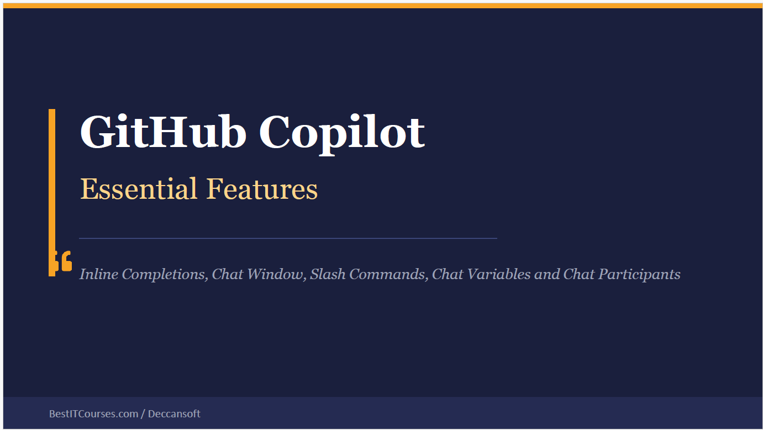
✍️ 1. Inline Completions
- What it is: Copilot suggests code directly in your editor as you type.
- How it works: It looks at your cursor position, open files, comments, and repo structure.
- Example:
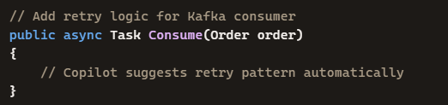
- Benefit: Fast, context-aware code suggestions without leaving your editor.
💬 2. Chat Window
- What it is: A side panel where you can ask Copilot questions in natural language.
- How it works: You can reference files (#file:OrderConsumer.cs), repo (#codebase), or external docs (#fetch).
- Example Prompt:
Code
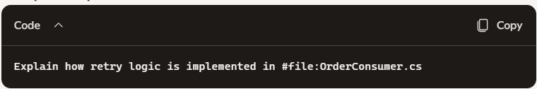
- Benefit: Richer answers than inline completions, because Copilot can pull from multiple sources.
⌨️ 3. Slash Commands
- What it is: Special commands you type in chat to control Copilot’s behavior.
- Examples:
  - /tests → Generate unit tests for selected code.
  - /doc → Create documentation for a function.
  - /compact → Summarize long chat history.
- Benefit: Quick shortcuts to trigger specific actions without long prompts.
📂 4. Chat Variables
- What it is: Variables that reference specific context objects like files, terminal output, or repo.
- Examples:
  - #file:OrderConsumer.cs → Points Copilot to that file.
  - #terminalSelection → Includes selected terminal output (errors/logs).
  - #codebase → Searches across the entire repo.
- Benefit: Precise control over what Copilot sees, reducing ambiguity.
👥 5. Chat Participants
- What it is: You can involve multiple “participants” in a chat, like Copilot Agent, GitHub Issues, or external tools.
- Example Scenario:
  - You ask Copilot Agent: “Fix failing Kafka consumer tests.”
  - It runs tests, reads errors, patches code, and retries.
- Benefit: Collaborative debugging and automation — Copilot doesn’t just answer, it acts.

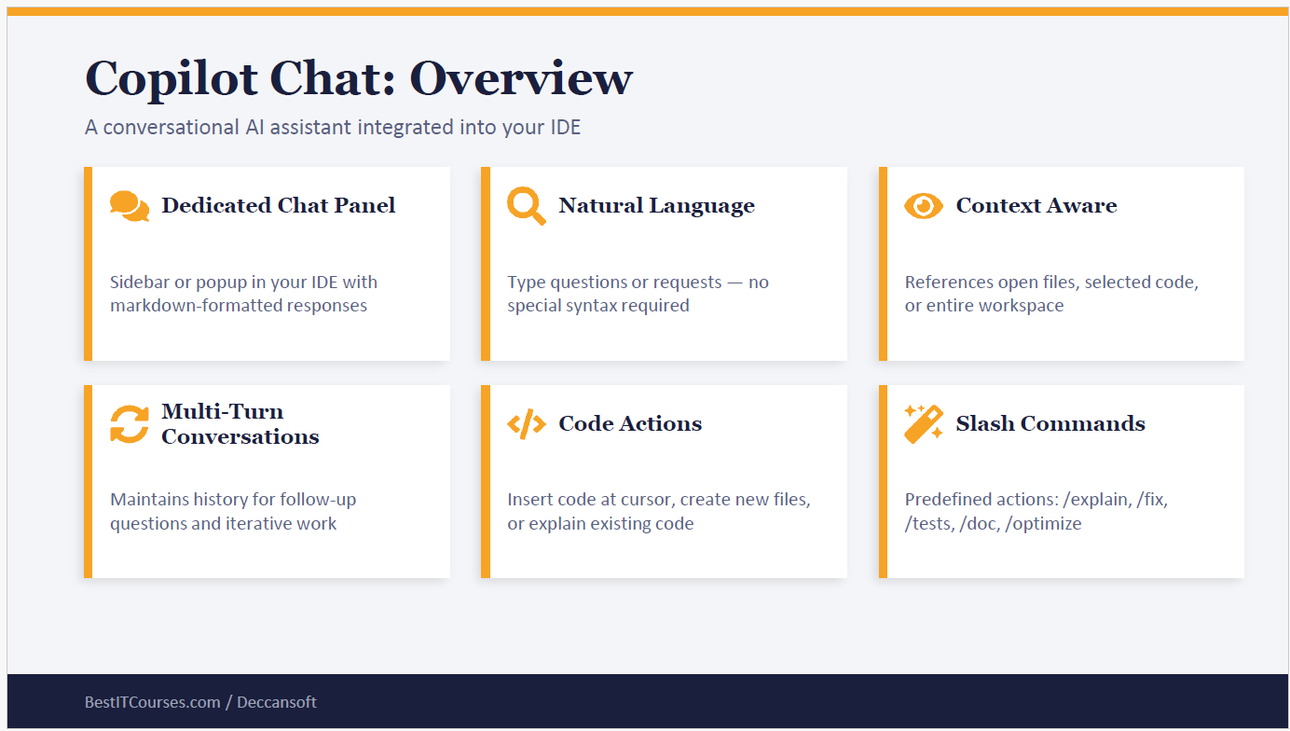

🔄 4. Multi-Turn Conversations
- What it is: Copilot remembers the history of your chat, so you can refine or follow up.
- Example:
  - First: “Explain how retries work in OrderConsumer.”
  - Then: “Now show me how to add logging to that retry logic.” Copilot connects the second request to the first answer without you repeating context.
⚡ 5. Code Actions
- What it is: Copilot can insert code at your cursor, create new files, or explain existing code.
- Examples:
  - “Insert a retry policy snippet here.” → Copilot writes code at your cursor.
  - “Create a new file InventoryConsumer.cs with similar logic.” → Copilot generates a new file.
  - “Explain this function.” → Copilot breaks down the logic line by line.
⌨️ 6. Slash Commands
- What it is: Predefined shortcuts for common tasks.
- Examples:
  - /explain → Explains selected code.
  - /fix → Suggests fixes for errors.
  - /tests → Generates unit tests.
  - /doc → Creates documentation.
  - /optimize → Suggests performance improvements.
- Scenario: You select a failing test and type /fix. Copilot analyzes the error and suggests corrected code.
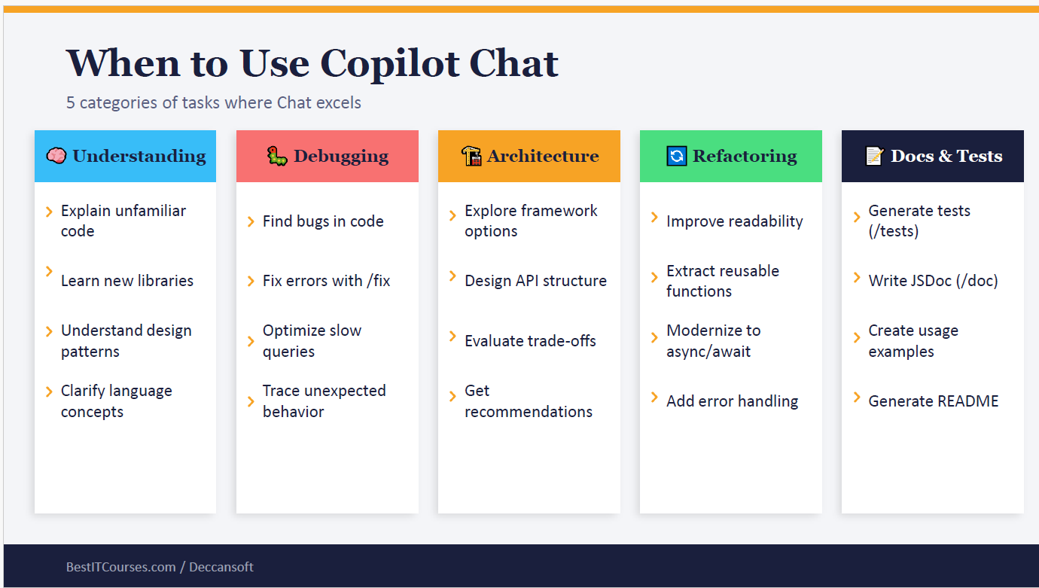
🧠 1. Understanding
- Purpose: Learn and clarify unfamiliar code, libraries, design patterns, or language concepts.
- Examples:
  - “Explain what this LINQ query does.”
  - “How does async/await work in C#?”
  - “Summarize the Singleton design pattern with code.”
- Scenario: You’re new to MassTransit Rider. You ask Copilot:
Code
Copilot explains the setup, consumer registration, and retry handling.
🐞 2. Debugging
- Purpose: Find bugs, fix errors, optimize queries, or trace unexpected behavior.
- Examples:
  - “Fix this error #terminalSelection” (Copilot uses your selected terminal output).
  - “Optimize this SQL query for performance.”
  - “Trace why this method returns null.”
- Scenario: Your Kafka consumer test fails. You ask:
Code

Copilot analyzes the log and suggests retry policy fixes.
🧰 3. Architecture
- Purpose: Explore frameworks, design APIs, evaluate trade-offs, and get recommendations.
- Examples:
  - “Compare gRPC vs REST for microservices.”
  - “Design an API structure for order management.”
  - “What are the trade-offs of event sourcing?”
- Scenario: You’re planning audit trails. You ask:
Code
Copilot suggests using a dedicated AuditConsumer with schema registry.
🔧 4. Refactoring
- Purpose: Improve readability, extract reusable functions, modernize code, or add error handling.
- Examples:
  - “Refactor this method into smaller functions.”
  - “Convert this synchronous code to async/await.”
  - “Add structured error handling here.”
- Scenario: You highlight a long method in OrderConsumer.cs and ask:
Code

Copilot splits it into smaller helper functions.
📄 5. Docs & Tests
- Purpose: Generate tests, documentation, usage examples, or README files.
- Examples:
  - /tests → Generate unit tests.
  - /doc → Create documentation for a function.
  - “Generate a README for this repo.”
- Scenario: You select PaymentConsumer.cs and type:
Code
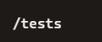
Copilot generates Arrange-Act-Assert style unit tests for the consumer.

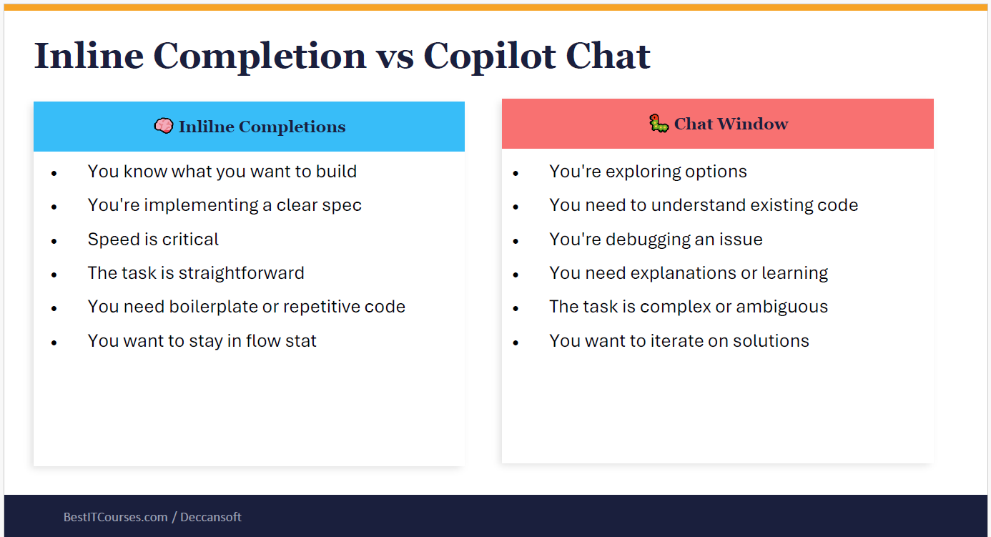
🔵 Inline Completions
This is Copilot’s “in-flow” mode — it suggests code directly in your editor as you type.
- You know what you want to build Example: You’re writing a Kafka consumer and already know the structure. Copilot autocompletes the Consume method with boilerplate code.
- You’re implementing a clear spec Example: You have a ticket: “Add retry logic with exponential backoff.” You start typing, and Copilot fills in the retry pattern.
- Speed is critical Example: You’re in a hackathon and need quick scaffolding. Inline completions generate repetitive code instantly.
- The task is straightforward Example: Adding a DTO class with properties. Copilot suggests the full class after you type the first property.
- You need boilerplate or repetitive code Example: Writing multiple unit tests with Arrange-Act-Assert. Copilot autocompletes the structure for each test.
- You want to stay in flow state Example: While coding continuously, you don’t break concentration — Copilot fills in snippets inline without switching to chat.
🔴 Copilot Chat Window
This is Copilot’s “exploration” mode — you ask questions in natural language, and Copilot pulls richer context.
- You’re exploring options Example: You ask:
Code
Should we use gRPC or REST for microservices? #codebase
Copilot explains trade-offs.
- You need to understand existing code Example: You ask:
Code
Explain how retry logic works in #file:OrderConsumer.cs
Copilot gives a step-by-step breakdown.
- You’re debugging an issue Example: You paste terminal output with #terminalSelection:
Code
Resolve failing test #terminalSelection
Copilot analyzes logs and suggests fixes.
- You need explanations or learning Example: You ask:
Code
Teach me how async/await works in C#
Copilot explains with examples.
- The task is complex or ambiguous Example: You ask:
Code
Design an audit trail system for Kafka microservices
Copilot proposes architecture options.
- You want to iterate on solutions Example:
  - First: “Generate a retry policy for Kafka consumers.”
  - Then: “Now add structured logging with Serilog.” Copilot builds iteratively across multiple turns.

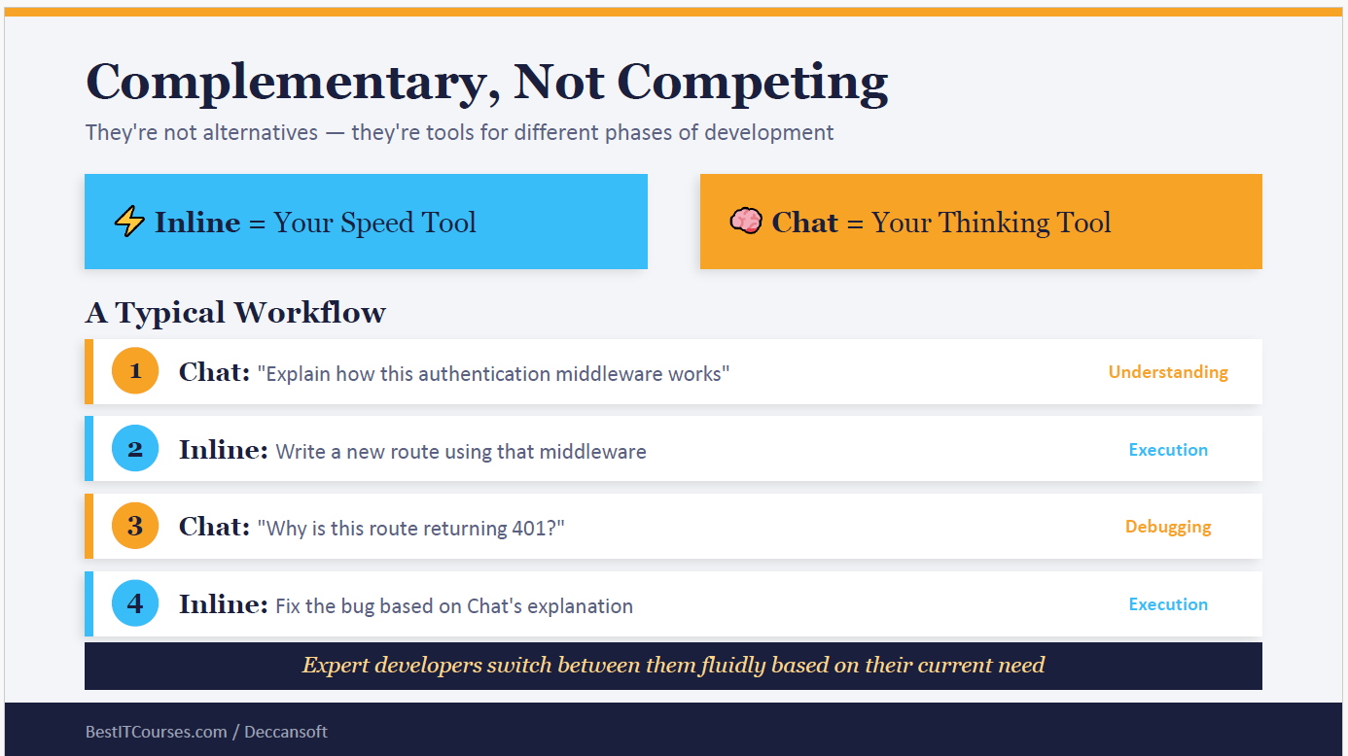
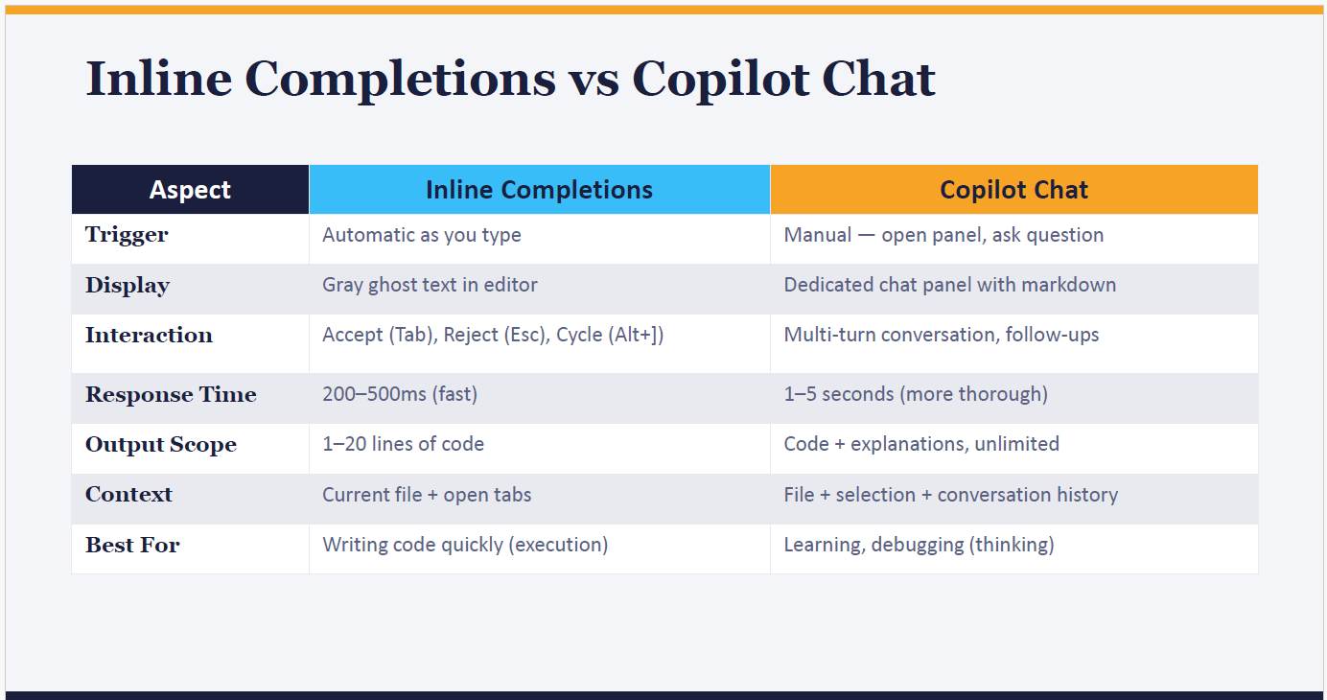
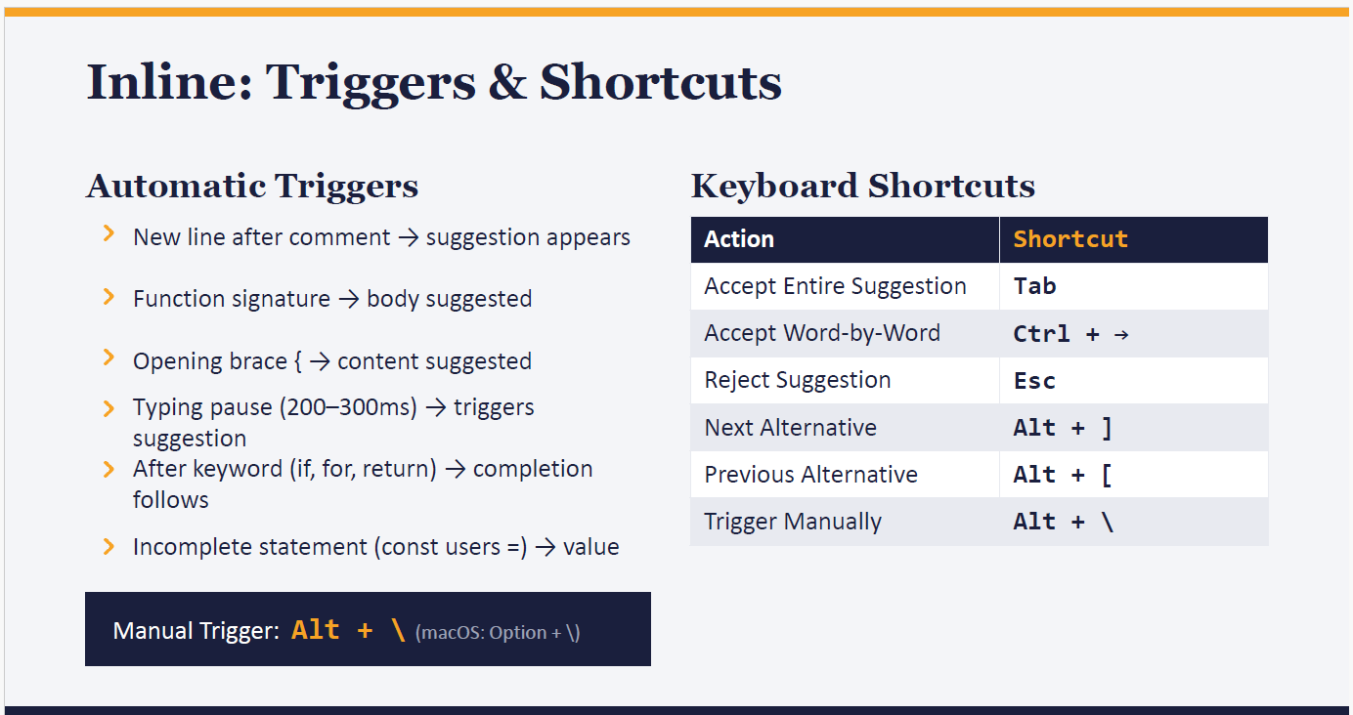
⚡ Automatic Triggers
These are situations where Copilot automatically shows a suggestion without you asking.
- New line after comment → suggestion appears
  - Example:
csharp
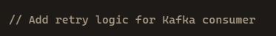
→ When you press Enter, Copilot suggests a retry pattern.
- Function signature → body suggested
  - Example:
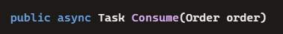
→ Copilot proposes the method body automatically.
- Opening brace { → content suggested
  - Example:
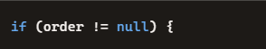
→ Copilot suggests the inside logic, like validation or logging.
- Typing pause (200–300ms) → triggers suggestion
  - Example: You type half a line, pause, and Copilot fills in the rest.
- After keyword (if, for, return) → completion follows
  - Example:

→ Copilot suggests the loop completion.
- Incomplete statement (const users =) → value
  - Example:

→ Copilot suggests await getUsers() or a default array.
👉 Manual Trigger: If you want to force a suggestion, press Alt + \\ (macOS: Option + \\).

⌨️ Keyboard Shortcuts
These let you control Copilot’s suggestions.
Action | Shortcut | Example
Accept Entire Suggestion | Tab | Copilot suggests a full retry policy → press Tab to accept.
Accept Word-by-Word | Ctrl + → | Copilot suggests a long line → accept it piece by piece.
Reject Suggestion | Esc | Copilot suggests code you don’t want → press Esc to dismiss.
Next Alternative | Alt + ] | Cycle through multiple suggestions Copilot offers.
Previous Alternative | Alt + [ | Go back to the earlier suggestion.
Trigger Manually | Alt + \\ | Force Copilot to show a suggestion even if it didn’t appear.

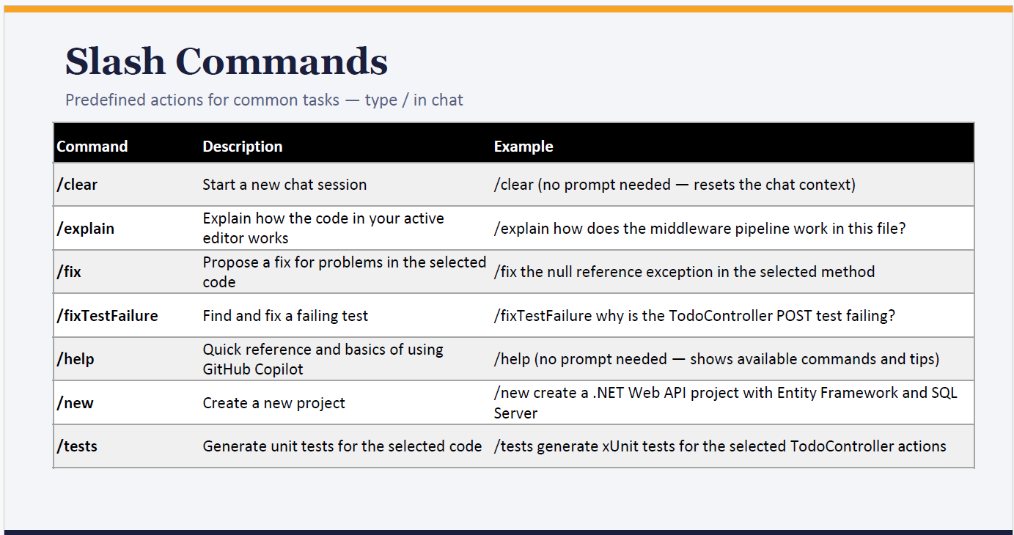

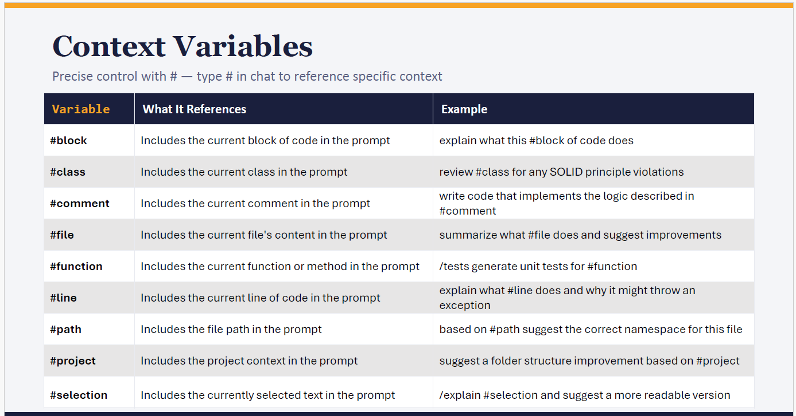
🔹 1. #block
- What it references: The current block of code (e.g., inside a method or loop).
- Example Prompt:
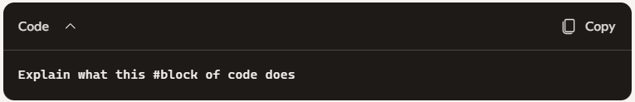
Scenario: You highlight a try-catch block in your Kafka consumer. Copilot explains how exceptions are handled in that block.
🔹 2. #class
- What it references: The entire class you’re working in.
- Example Prompt:
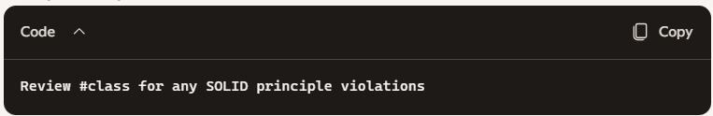
Scenario: You ask Copilot to check OrderConsumer.cs. It reviews the whole class and suggests refactoring if it violates Single Responsibility or Dependency Inversion.
🔹 3. #comment
- What it references: The current comment in your code.
- Example Prompt:
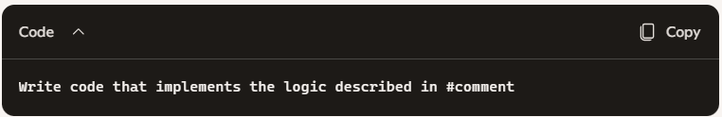
Scenario: You write // Add retry logic with exponential backoff. Copilot generates the retry code based on that comment.
🔹 4. #file
- What it references: The entire file’s content.
- Example Prompt:
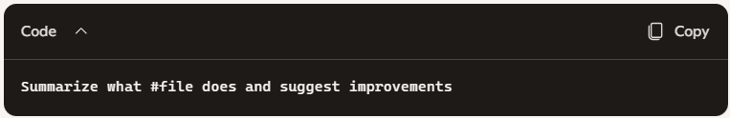
Scenario: You ask Copilot to summarize PaymentConsumer.cs. It explains the consumer’s role and suggests improvements like better error handling.
🔹 5. #function
- What it references: The current function or method.
- Example Prompt:
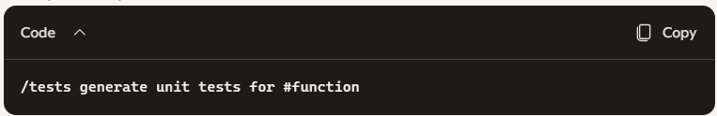
Scenario: You highlight Consume(Order order) in OrderConsumer.cs. Copilot generates Arrange-Act-Assert style unit tests for that function.
🔹 6. #line
- What it references: The current line of code.
- Example Prompt:
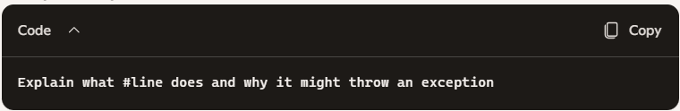
Scenario: You select order.TotalAmount.Value. Copilot explains that if TotalAmount is null, this line throws a NullReferenceException.
🔹 7. #path
- What it references: The file path.
- Example Prompt:
- 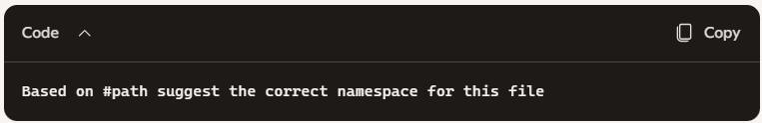Scenario: File path is src/Consumers/OrderConsumer.cs. Copilot suggests namespace Project.Consumers.
🔹 8. #project
- What it references: The entire project context.
- Example Prompt:
- 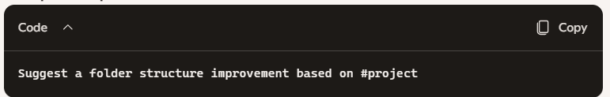Scenario: Copilot reviews your microservices project and suggests separating Consumers, Services, and Infrastructure folders for clarity.
🔹 9. #selection
- What it references: The text you’ve selected in the editor.
- Example Prompt:
- 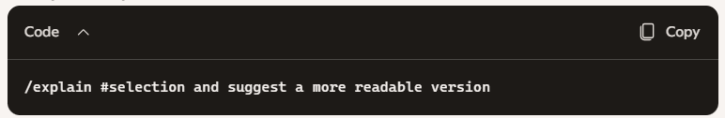Scenario: You select a long LINQ query. Copilot explains it and suggests breaking it into smaller steps for readability.

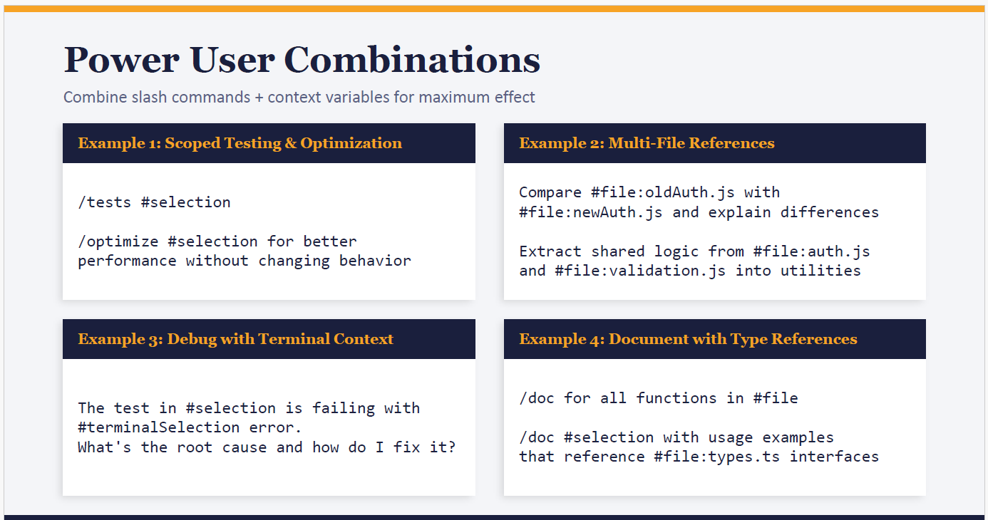
⚡ Example 1: Scoped Testing & Optimization
- Command:
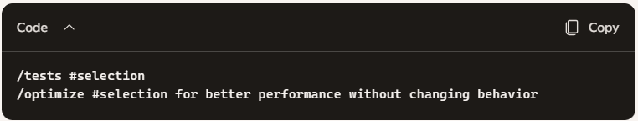
What it does:
  - /tests #selection → Generates unit tests for the code you’ve highlighted.
  - /optimize #selection → Suggests performance improvements for that same code block.
- Scenario: You select a LINQ query in OrderConsumer.cs.
  - Copilot first generates unit tests to validate correctness.
  - Then it optimizes the query (e.g., replacing nested loops with efficient joins).
📂 Example 2: Multi-File References
- Command:
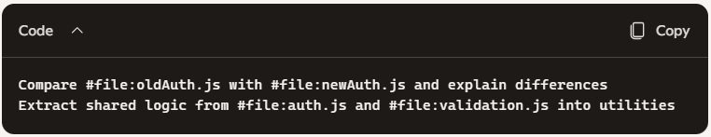
Extract shared logic from #file:auth.js and #file:validation.js into utilities
- What it does:
  - Compares two files side by side.
  - Extracts common logic into reusable utility functions.
- Scenario: You’re migrating authentication logic.
  - Copilot highlights differences between old and new implementations.
  - Then it refactors shared validation logic into a Utilities.cs file.
🐞 Example 3: Debug with Terminal Context
- Command:
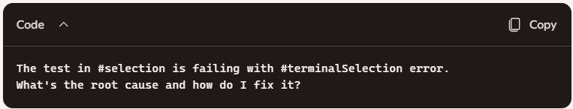
What's the root cause and how do I fix it?
- What it does:
  - Combines selected test code (#selection) with actual error logs (#terminalSelection).
  - Copilot diagnoses the issue and suggests a fix.
- Scenario: Your Kafka consumer test fails.
  - You select the failing test.
  - You also include the terminal error output.
  - Copilot pinpoints that retry logic isn’t applied and suggests updating RetryPolicy.cs.
📄 Example 4: Document with Type References
- Command:
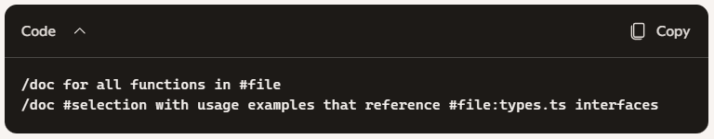
What it does:
  - /doc generates documentation for functions.
  - It can also create usage examples referencing type definitions.
- Scenario: You’re documenting PaymentConsumer.cs.
  - Copilot generates XML or JSDoc comments for each function.
  - For selected code, it adds usage examples referencing types.ts interfaces (e.g., Payment type).
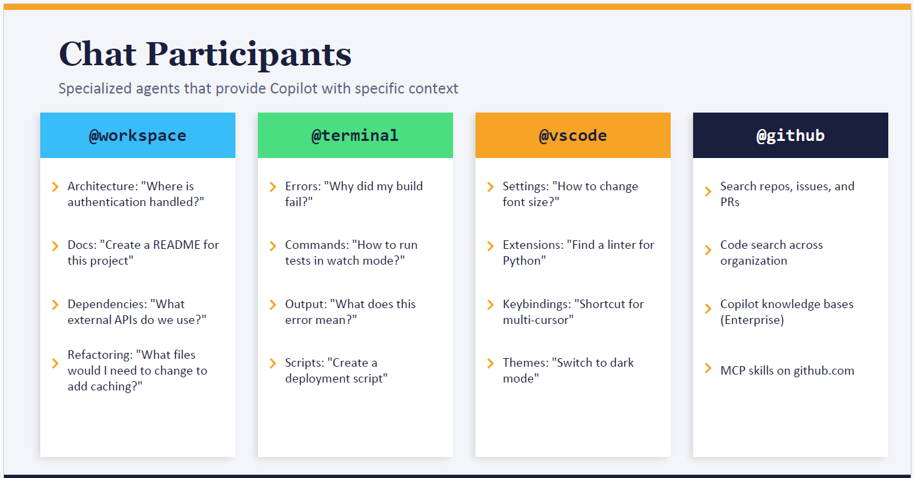
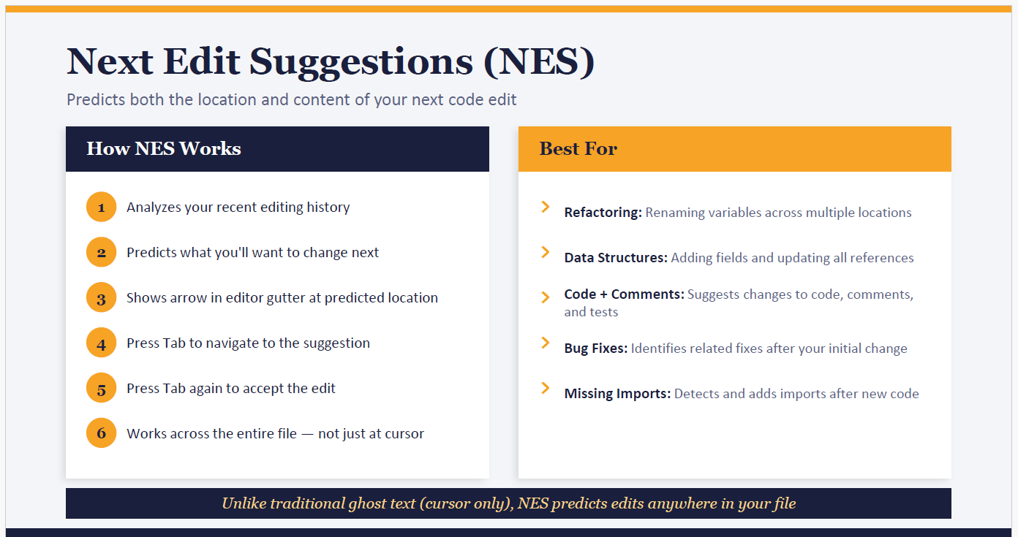

Module 5:
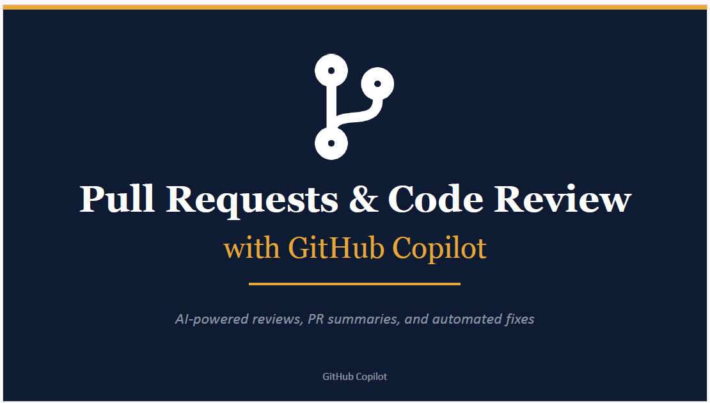
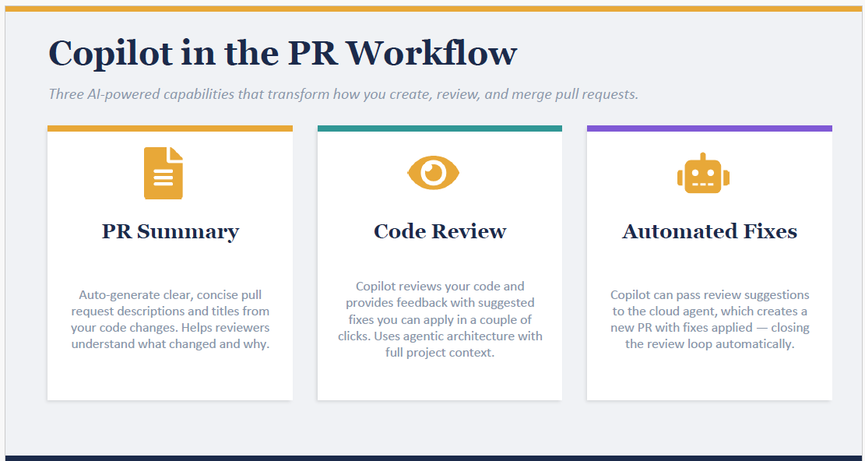
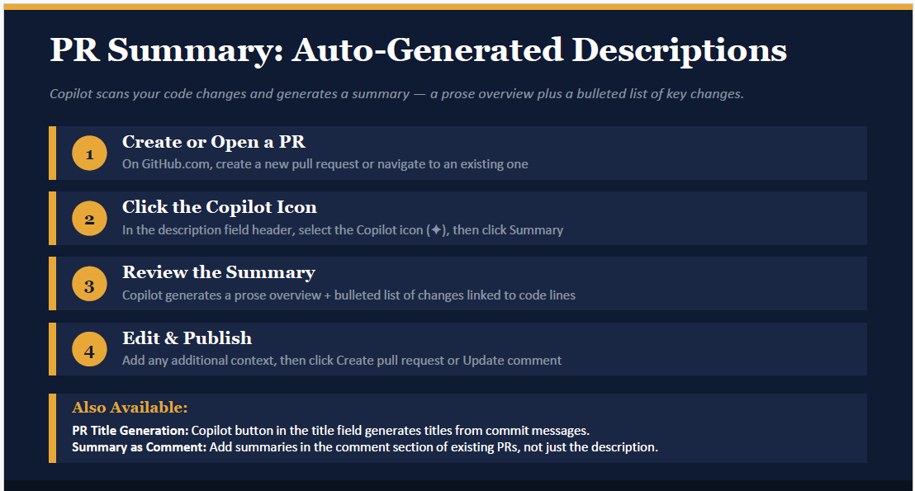
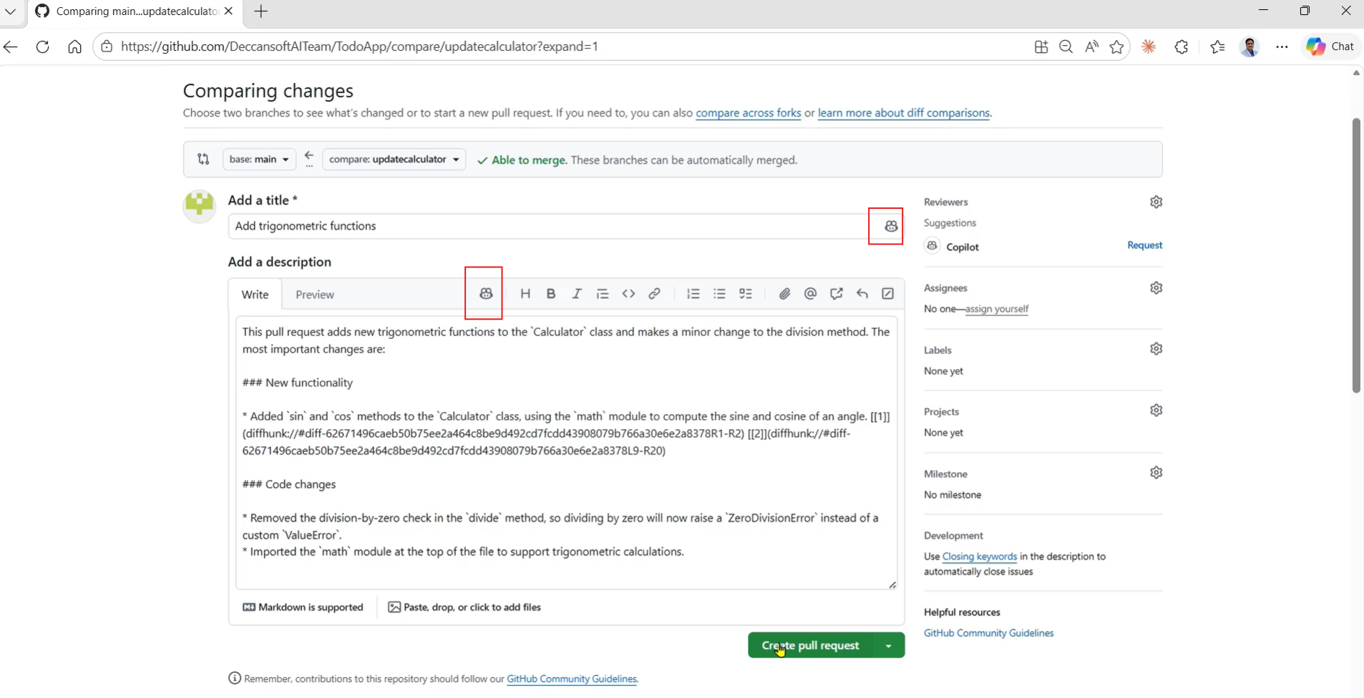
We can generate commit message by copilot , According to changes implemented message will be generated.
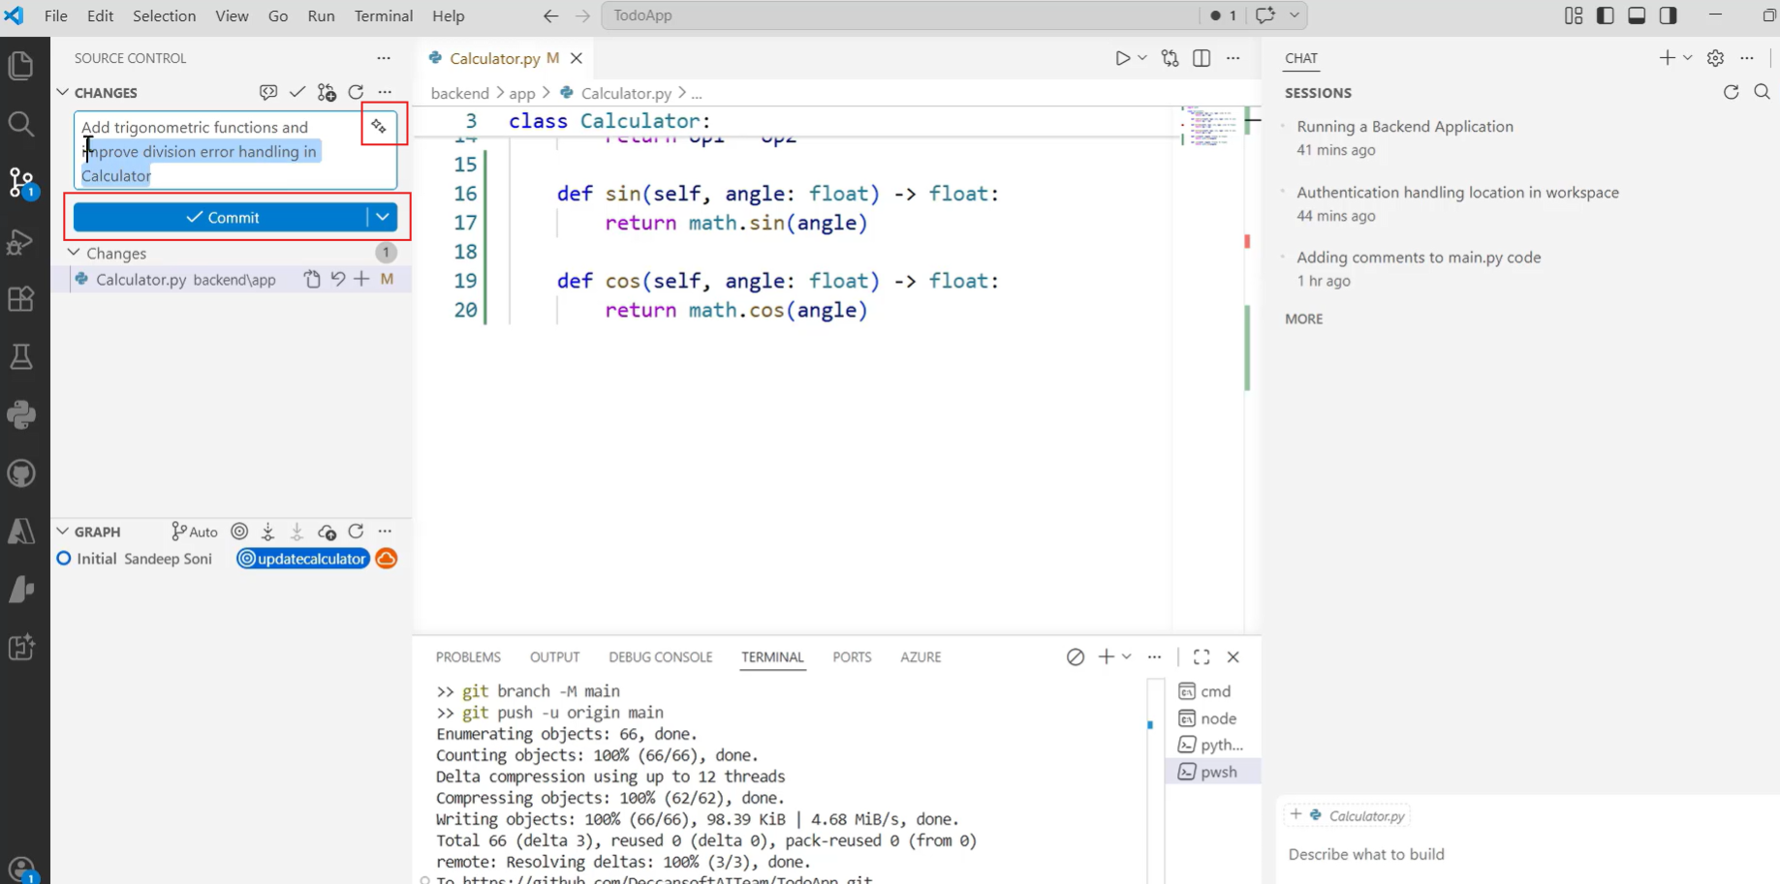
We can ask copilot to review before PR create??
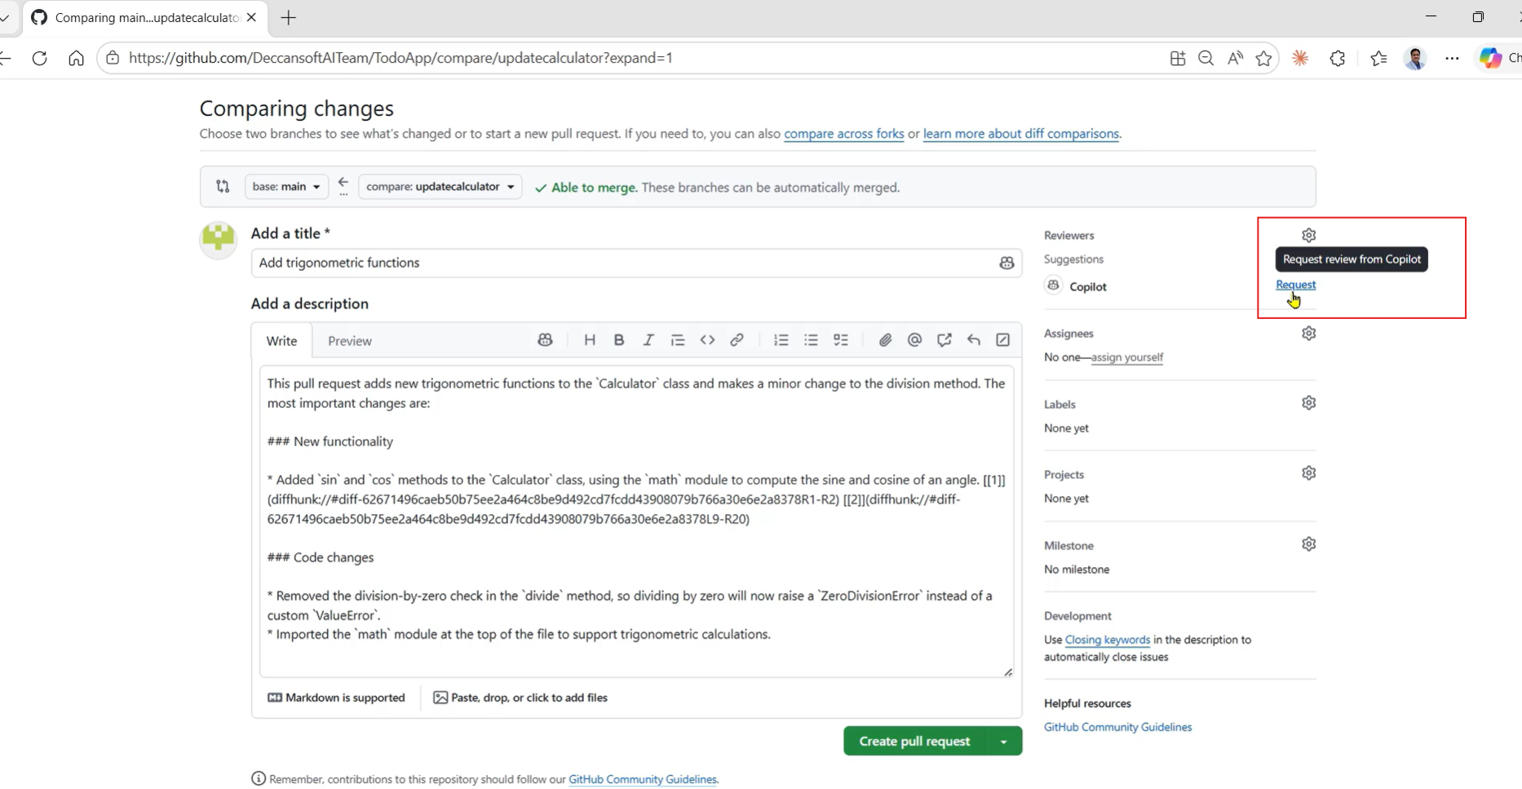

🔍 How Copilot Reviews Code Before PR
Copilot can act like a pre-PR reviewer inside your IDE or chat window:
- Use Context Variables
  - Example:
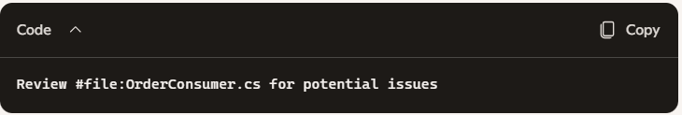
  - Copilot scans the file and points out problems (e.g., missing null checks, retry logic gaps).
- Use Slash Commands
  - /explain #selection → Explains selected code.
  - /fix #selection → Suggests fixes before you commit.
  - /tests #function → Generates unit tests to validate logic.
  - This lets you catch issues before pushing code.
- Architecture & Standards Review
  - Example:
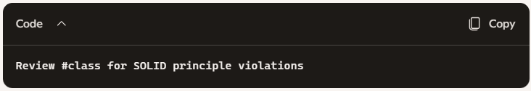
  - Copilot checks if your class is too large, has multiple responsibilities, or violates dependency inversion.
- Security & Best Practices
  - Example:
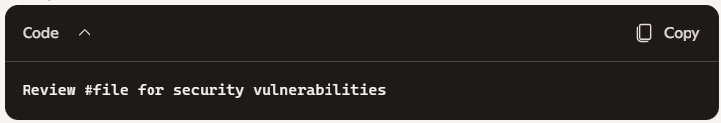
  - Copilot highlights unsafe patterns (e.g., hardcoded secrets, missing input validation).
📂 Practical Scenario (Kafka + MassTransit)
Imagine you’re about to commit changes to PaymentConsumer.cs:
- You ask Copilot:
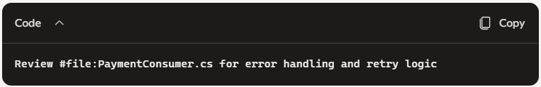
- Copilot responds:
  - Notes missing null checks on Payment object.
  - Suggests aligning retry logic with RetryPolicy.cs.
  - Recommends structured logging with Serilog.
You fix these issues before creating the PR, so your PR summary later is cleaner and reviewers see fewer problems.
✅ Key Takeaway
- Yes, Copilot can review code before PR creation.
- Use chat variables (#file, #class, #function, #selection) + slash commands (/fix, /tests, /explain).
- This acts like a pre-commit reviewer, helping you improve code quality before opening a PR.
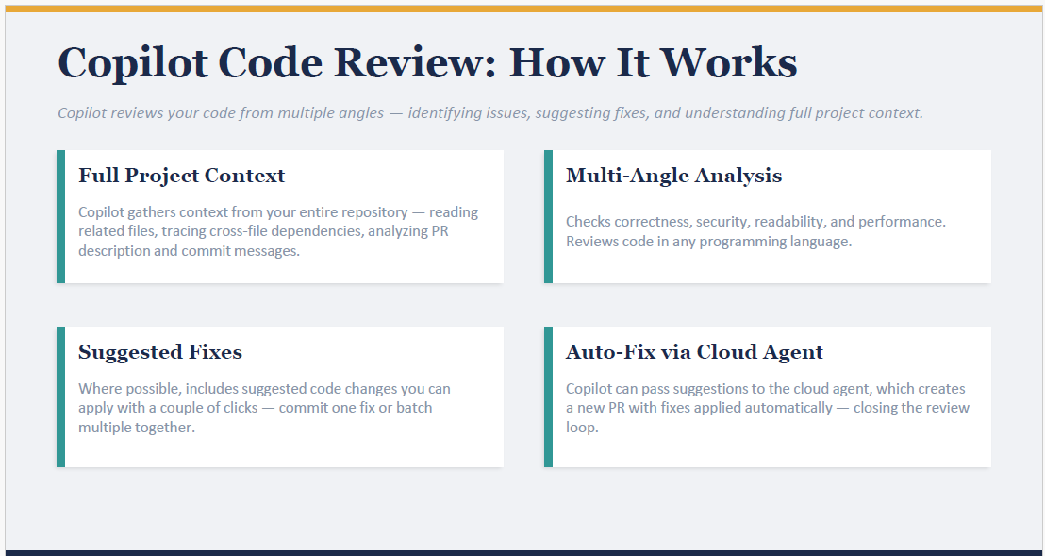
We can delegate

In next steps 1st assign code review to copilot
1 PR review = 1 Premium request
What is Premium request??

Above manual step we can automat by enable setting in github copilot setting
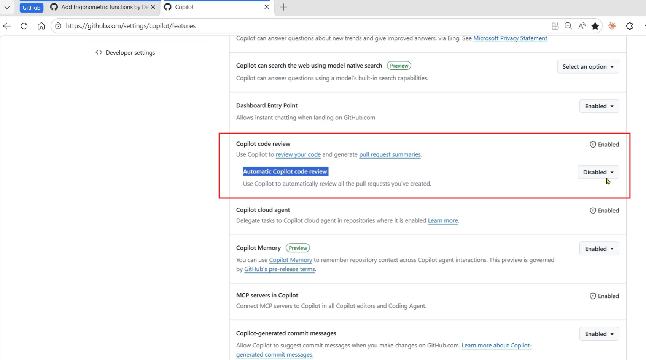

In GitHub Copilot Browser, During PR we can chat and give instructions also.
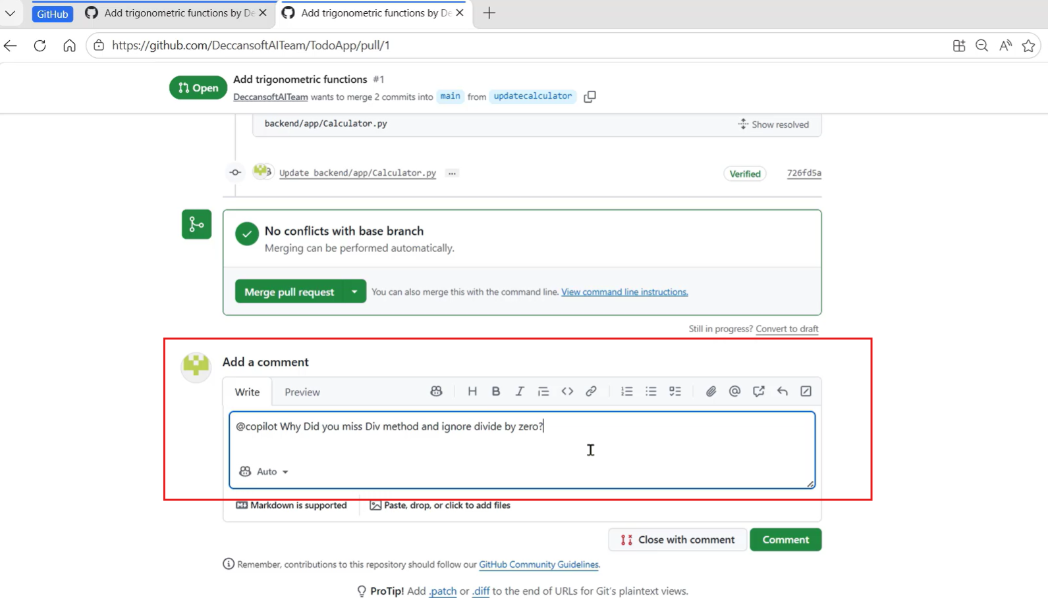

We can also preform Code review from VS chat winfow
1st select ask mode
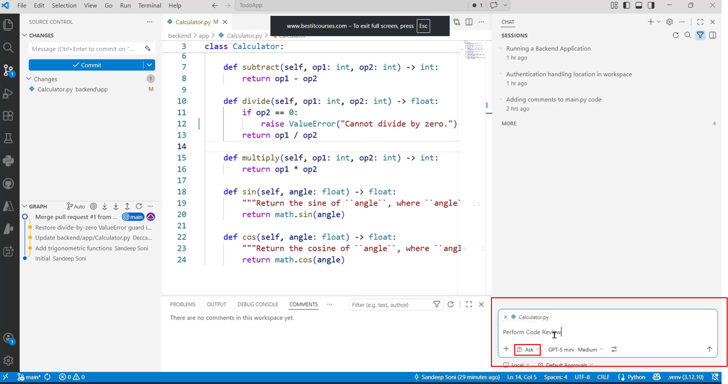
If I want’s to review complete code base then
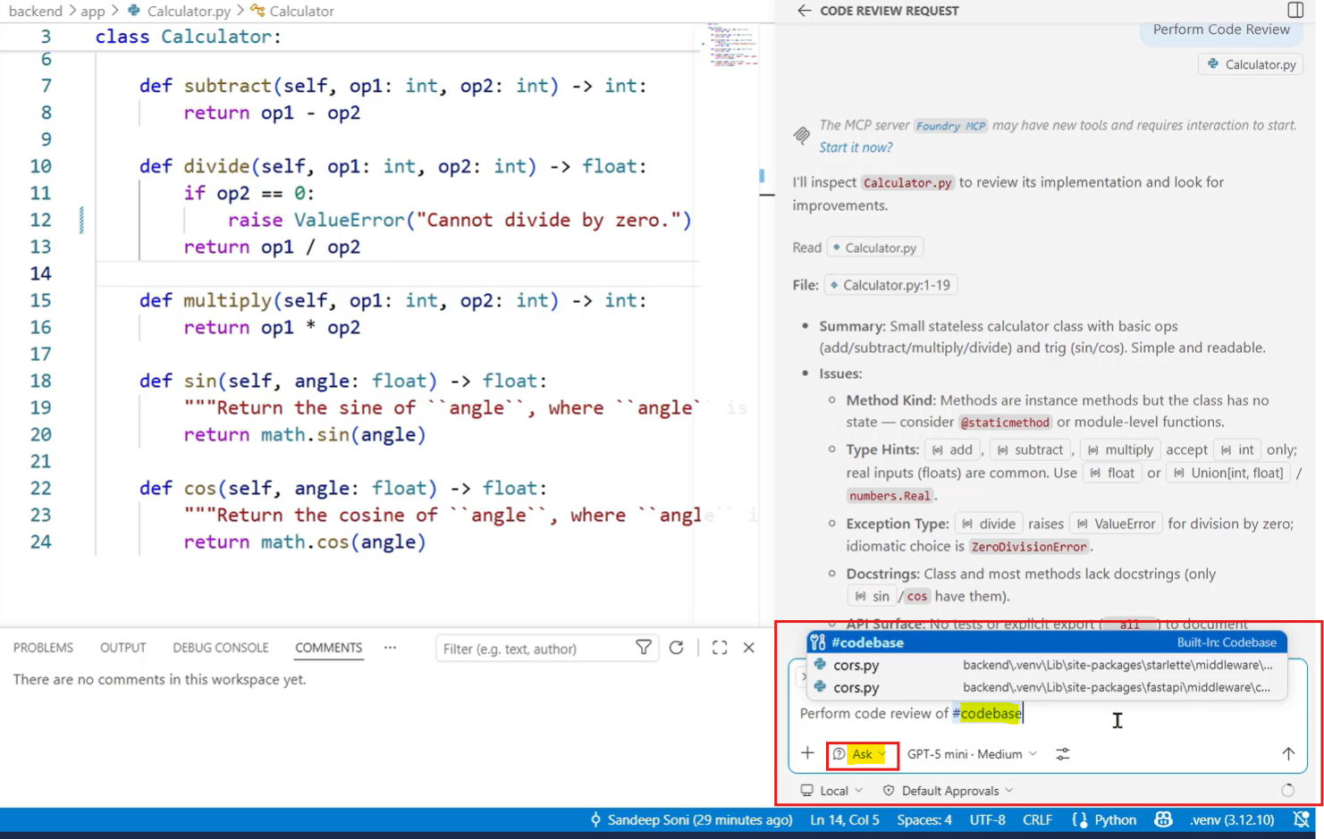
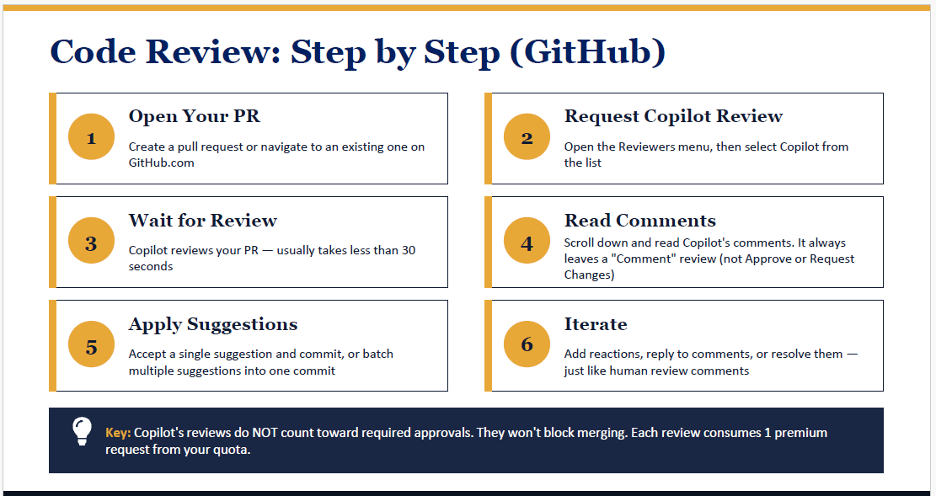
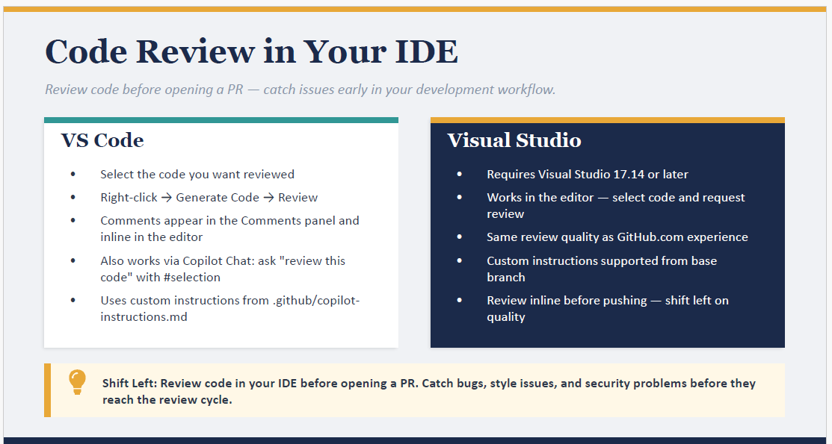
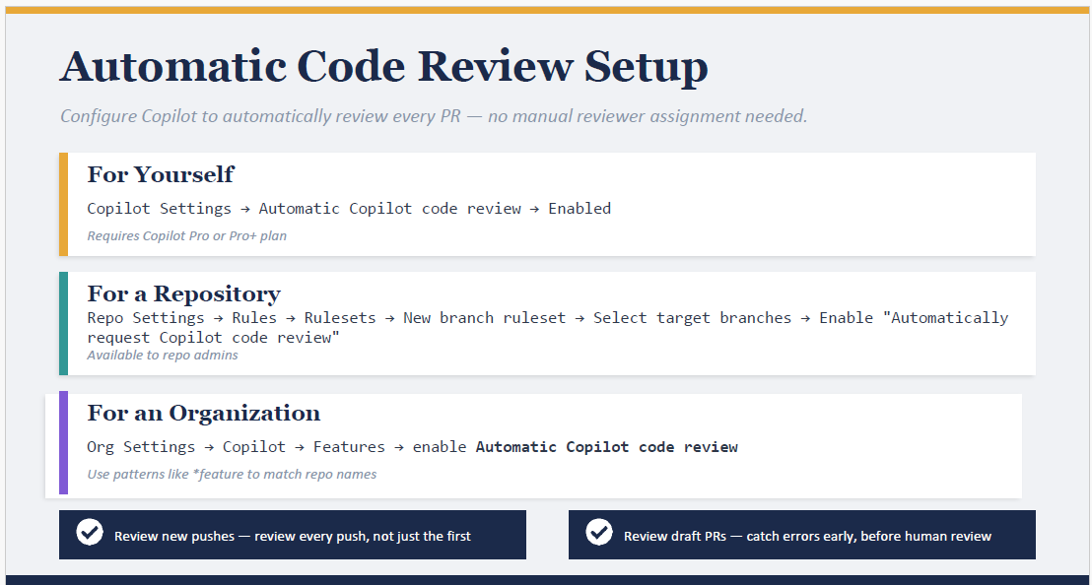
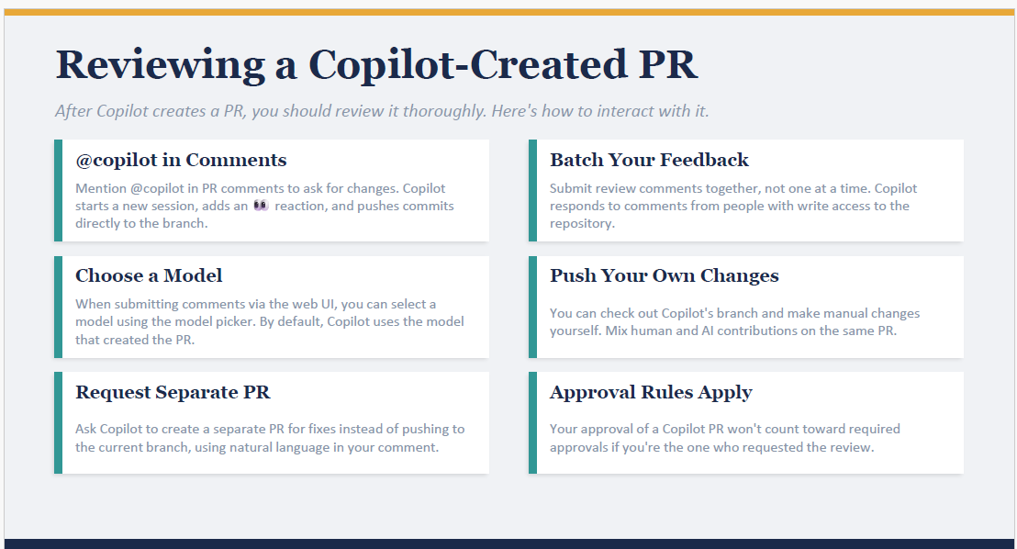
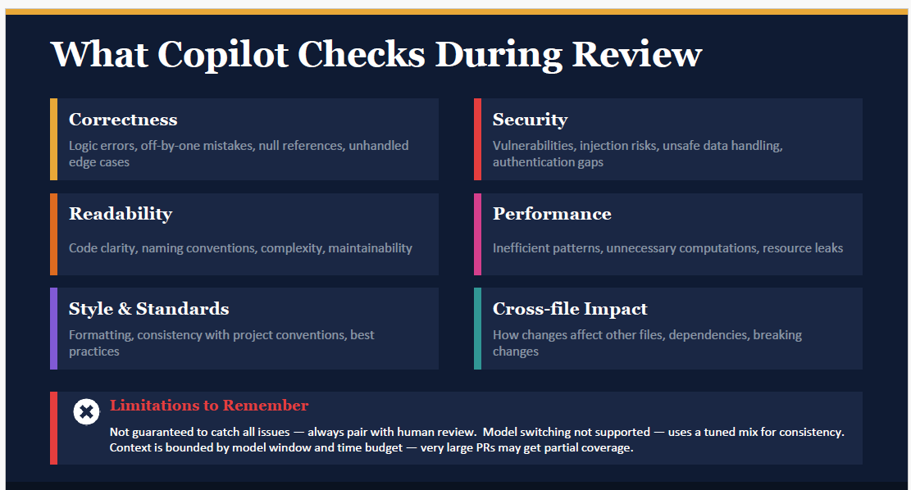
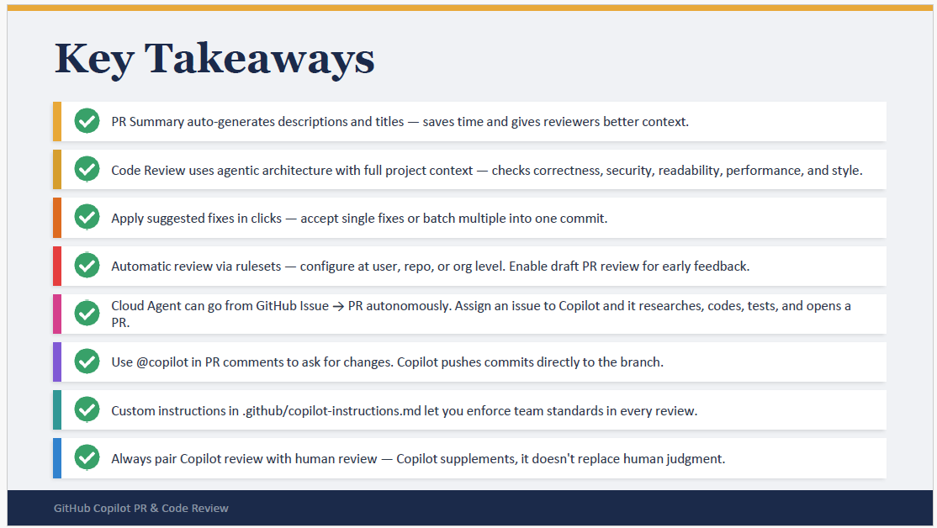

Module 6:
